1642. Furthest Building You Can Reach
Medium

You are given an integer array heights representing the heights of buildings, some bricks, and some ladders.
You start your journey from building 0 and move to the next building by possibly using bricks or ladders.
While moving from building i to building i+1 (0-indexed),
- If the current building's height is greater than or equal to the next building's height, you do not need a ladder or bricks.
- If the current building's height is less than the next building's height, you can either use one ladder or (h[i+1] - h[i]) bricks.
Return the furthest building index (0-indexed) you can reach if you use the given ladders and bricks optimally.

Example 1:
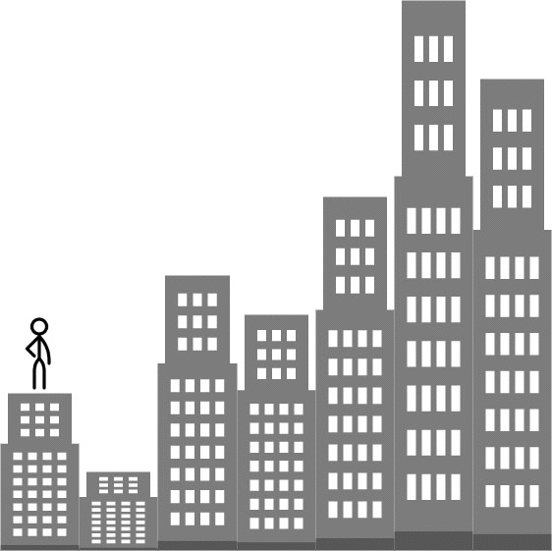
Input: heights = [4,2,7,6,9,14,12], bricks = 5, ladders = 1
Output: 4
Explanation: Starting at building 0, you can follow these steps:
- Go to building 1 without using ladders nor bricks since 4 >= 2.
- Go to building 2 using 5 bricks. You must use either bricks or ladders because 2 < 7.
- Go to building 3 without using ladders nor bricks since 7 >= 6.
- Go to building 4 using your only ladder. You must use either bricks or ladders because 6 < 9.
It is impossible to go beyond building 4 because you do not have any more bricks or ladders.
Example 2:
Input: heights = [4,12,2,7,3,18,20,3,19], bricks = 10, ladders = 2
Output: 7
Example 3:
Input: heights = [14,3,19,3], bricks = 17, ladders = 0
Output: 3

Constraints:
- 1 <= heights.length <= 105
- 1 <= heights[i] <= 106
- 0 <= bricks <= 109
- 0 <= ladders <= heights.length

